** MINISTRY OF EDUCATION AND TRAINING**

**FPT UNIVERSITY**

Capstone Project Document

Student Finance Management

|  |  |
| --- | --- |
| **Group 2** | |
| **Group members** | Tran Khac Vy – Team Leader – SE60964  Ho Doan Trung – Team Member – SE60882  Tran Quang Phuc – Team Member - SE60993  Vu Nhat Anh Khoa – Team Member – SE60817  Le Tuan Anh – Team Member – SE60685 |
| **Supervisor** | Mr. Kieu Trong Khanh |
| **Ext. Supervisor** | N/A |
| **Capstone Project code** | SFM |

-Ho Chi Minh City, 09/2015-*This page is intentionally left blank*

***ACKNOWLEDGEMENTS***

We wish to thank various people for their contribution to this project: Our teachers for their advice and participation in the final review, our friends for their valuable technical support.

Special thanks should be given to Mr.Kiều Trọng Khánh, our research supervisor for his professional guidance and the useful, constructive recommendations throughout the course of this project.

# Table of Contents

Table of Contents 4

List of Tables 5

List of Figures 6

Definitions, Acronyms, and Abbreviations 8

Report No.3 Software Requirement Specification 9

1. User Requirement Specification 9

1.1 Guest Requirement 9

1.2 Member Requirement 9

1.3 Staff Requirement 9

1.4 Admin Requirement 9

1.5 System Requirement 9

2. System Requirement Specification 9

2.1 External Interface Requirement 9

2.2 System Overview Use Case 10

2.3 List of Use Case 10

3. Software System Attribute 48

3.1 Usability 48

3.2 Reliability 48

3.3 Availability 48

3.4 Security 48

3.5 Maintainability 48

3.6 Portability 48

3.7 Performance 49

4. ERD 50

# List of Tables

# List of Figures

# Definitions, Acronyms, and Abbreviations

|  |  |
| --- | --- |
|  |  |

# Software Requirement Specification

## User Requirement Specification

### Guest Requirement

Guest is a person who doesn’t have access to the system. To use all functions, guest must login. This is a function guest can use:

* Login

### Student Requirement

Student is people who use the services of the system. In the current system there are 3 types of student are:

• Student common

• Student credit loans

• Students in the form of "Together you invest"

All the students were able to use some of the functions below:

• Review the learning process

o View the semester learned

o See the list of unfinished subjects (including arts subjects are owed or not eligible to attend if any)

• Review financial condition

o View the page of the tuition payment period studied

o See characteristics of the subjects pay tuition debt (if any)

o View the total amount borrowed and the interest to the present time

• View and update personal information

### Staff Requirement

Employees who manage the information related to students, academic and financial. The system classifies employees into three categories as follows:

• Student affairs

* Manage the list of students

• Training Management

* Manage the learning outcomes of students

•Financial management

* Manage tuition rates
* Management Beginning proceeds

### Manager Requirement

Manager who controls financial information on the learning process of students, besides manager manages the exchange rate and the amount corresponding to the school credit courses. Manager can:

* View Finance Information
* Manage Academic Suspension
* Manage Exchange Rate

### Admin Requirement

Admin is the person who manages the system. Admin can use these functions:

* Configure system.
* Manage Course.
* Manage user.

## System Requirement Specification

#### External Interface Requirement

##### User Interface

* General requirement for graphics user interface is the GUI should be simple, clear, intuitive, and reminiscent.
* The interface design is an iterate process includes: design, sketching, prototyping, user assessment.
* Some design principles will be taken into consideration:
  + UI for business web applications - Janko Jovanovic [Ref:http://www.smashingmagazine.com/2010/02/25/designing-user-interfaces-forbusiness-web-applications/]
  + Ten principles of effective web design – Vitaly Friedman [Ref:http://www.smashingmagazine.com/2008/01/31/10-principles-of-effective-webdesign/]

##### Hardware Interface

**N/A**

##### Software Interface

* Web application: works with Firefox (v30 or above), Chromes (v14 or above), Internet Explorer (v10 or above) browse.

##### Communication Protocol

* Use HTTP protocol 1.1 for communication between the web browser and the web server.

#### System Overview Use Case

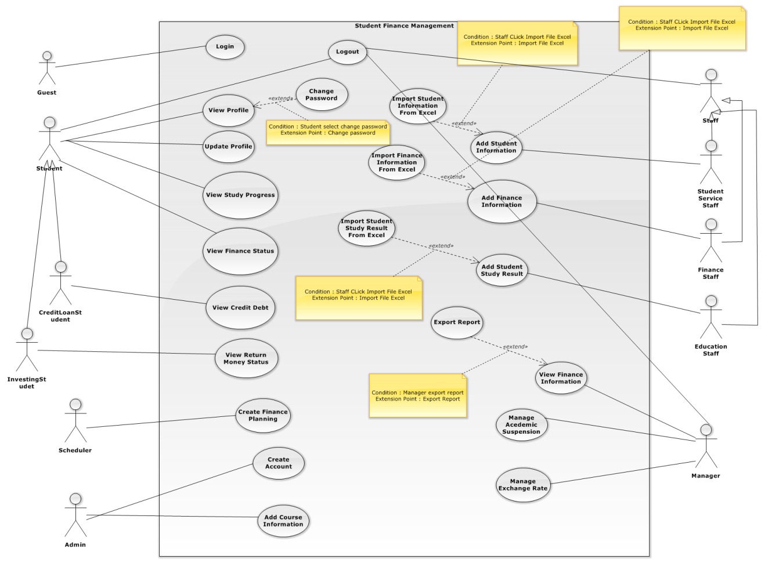

Figure 1: System Overview Use Case

#### List of Use Case

##### <Guest> Overview Use Case

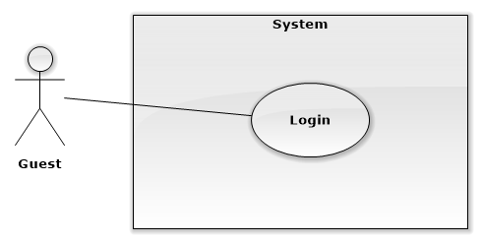

**Figure 1: <Guest> Overview Use Case**

###### <Guest> Login Use Case Diagram



**Figure 2: <Guest> Login Use Case Diagram**

|  |  |  |  |
| --- | --- | --- | --- |
| USE CASE – Guest01 | | | |
| Use Case No. | WG01 | Use Case Version | 1.0 |
| Use Case Name | Login | | |
| Author | TrungHD | | |
| Date | 06/10/2015 | Priority | Normal |
| Actor:   * Guest   Summary:   * This use case allows guest to log in the system.   Goal:   * Guest can log in the system. Therefore, they can use some additional functions.   Triggers:   * Guest sends the login command.   Preconditions:   * N/A   Post Conditions:   * Success: Guest login the system. * Fail: Show error message.   Main Success Scenario:   |  |  |  | | --- | --- | --- | | **Step** | **Actor Action** | **System Response** | | 1 | Guest goes to login view. | System requires identity information form Guest:   * Username: Free text input, required, length 6 - 250 * Password: Password input, required, length 8 - 32 | | 2 | Guest input information. |  | | 3 | Guest sends command to login to system. | Guest will login system with their specific role.  [Alternative 1]  [Exception 1] |   Alternative Scenario[1]:   |  |  |  | | --- | --- | --- | | **Step** | **Actor Action** | **System Response** | | 1 | Guest enters wrong identity information. | System shows error message. |   Exceptions[1]:   |  |  |  | | --- | --- | --- | | **Step** | **Actor Action** | **System Response** | | 1 | Guest enters wrong identity information. | System shows error message. |   Relationships: N/A  Business Rules:   * Password is encrypted before being sent to server. * After login to system, guest will be redirected to specific view based on their role on the system: student, staff, manager or admin. * If role is “Student”, the system will display to Student view. * If role is “Staff”, the system will display to Staff view. * If role is “Manager”, the system will display to Manager View. | | | |

##### <Student> Overview Use Case

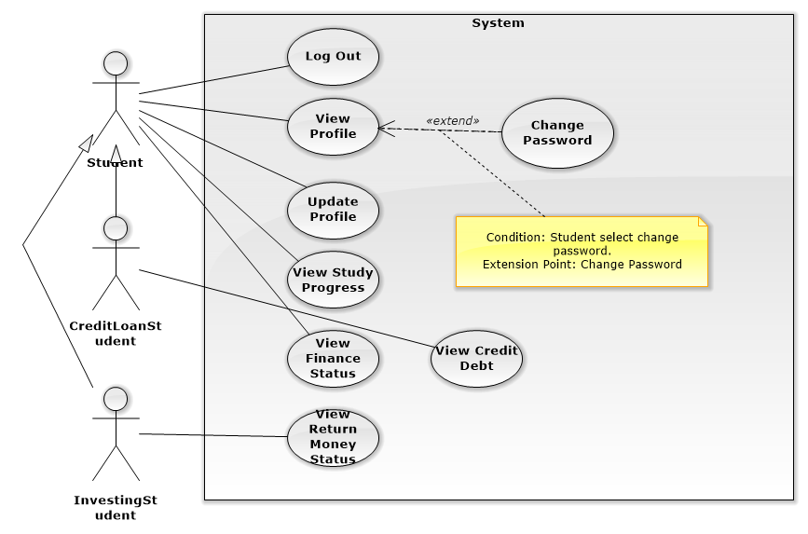

Figure 3: <Student> Overview Use Case

###### <Student> Log out Use Case Diagram

###### <Student> View Profile Use Case Diagram

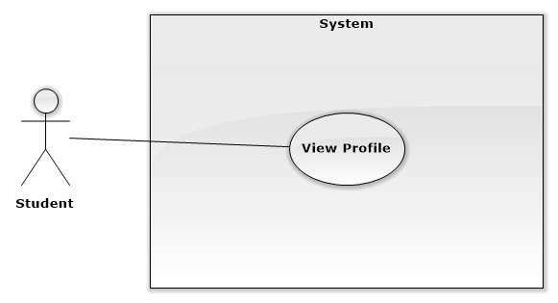

**Figure 4: <Student> View Profile Use Case Diagram**

|  |  |  |  |
| --- | --- | --- | --- |
| **USE CASE – STU001** | | | |
| **Use Case No.** | WS01 | **Use Case Version** | 1.0 |
| **Use Case Name** | View Profile | | |
| **Author** | Vu Nhat Anh Khoa | | |
| **Date** | 26/09/2015 | **Priority** | Normal |
| **Actor:**   * Student   **Summary:**   * This use case allows users to view their personal information.   **Goal:**   * User can review their card information.   **Triggers:**   * User sends view profile command   **Preconditions:**   * User logs in with Student role   **Post Conditions:**   * **Success**: The system successfully shows user’s profile information * **Fail:** The system shows an error message.   **Main Success Scenario:**   |  |  |  | | --- | --- | --- | | Step | Actor Action | System Response | | 1 | User sends view profile command | Navigate user to their Profile screen and show information box containing detail information including:   * + User’s full name labeled as “Tên”: text.   + User’s code labeled as “MSSV”: text.   + User’s personal identification number labeled as “CMND”: text.   + User’s tuition status labeled as “Tình trạng”: text   + The year user started school labeled as “Khóa nhập học”: text   + User’s gender labeled as “Giới tinh”: text   + User’s day of birth labeled as “Ngày sinh”: text   + User’s address labeled as “Địa chỉ”: text   + User’s phone number labeled as “Số điện thoại”: text   + User’s email address labeled as “Email”: text   + The phone number of user’s parent labeled as “Số điện thoại của phụ huynh”: text   + The email address of user’s parent labeled as “Email của phụ huynh”: text |   **Alternative Scenario:**   |  |  |  | | --- | --- | --- | | Step | Actor Action | System Response | | 1 | User clicks the link of their name at the top right of the screen | Navigate user to their Profile screen and show information box containing detail information including:   * + User’s full name labeled as “Tên”: text.   + User’s code labeled as “MSSV”: text.   + User’s personal identification number labeled as “CMND”.   + User’s tuition status labeled as “Tình trạng”: text   + The year user started school labeled as “Khóa nhập học”: text   + The English level when user started school labeled as “Tiếng Anh đầu vào”: text   + User’s gender labeled as “Giới tính”: text   + User’s day of birth labeled as “Ngày sinh”: text   + User’s address labeled as “Địa chỉ”: text   + User’s phone number labeled as “Số điện thoại”: text   + User’s email address labeled as “Email”: text   + The phone number of user’s parent labeled as “Số điện thoại của phụ huynh”: text   + The email address of user’s parent labeled as “Email của phụ huynh”: text |   **Exceptions:**   |  |  |  | | --- | --- | --- | | No | Actor Action | System Response | | 1 | Cannot connect to server. | System shows error message: “Cannot connect to server.” |   **Relationships:** N/A  **Business Rules:**   * The system fetches user only their own profile information from the database. | | | |

###### <Student> Change Password Use Case Diagram

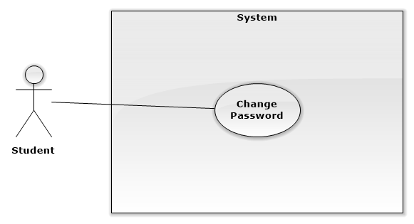

Figure : <Student> Change Password Use Case Diagram

|  |  |  |  |
| --- | --- | --- | --- |
| **USE CASE – STU003** | | | |
| **Use Case No.** | STU003 | **Use Case Version** | 1.0 |
| **Use Case Name** | Change Password | | |
| **Author** | Vu Nhat Anh Khoa | | |
| **Date** | 25/09/2015 | **Priority** | Normal |
| **Actor:**   * Student   **Summary:**   * This use case allows users to change their password accounts.   **Goal:**   * New password is updated to database.   **Triggers:**   * User clicks “Đổi password” link while on the Profile screen.   **Preconditions:**   * User logs in with Student role   **Post Conditions:**   * **Success**: The system successfully updates new password to database. * **Fail:** The system shows an error message.   **Main Success Scenario:**   |  |  |  | | --- | --- | --- | | Step | Actor Action | System Response | | 1 | User clicks “Đổi password” link from Profile screen | Navigate user to Change Password screen and show the following form:   * + Label: “Password hiện tại”, Textbox: free text input, required, length 6-32   + Label: “Password mới”, Textbox: free text input, required, length 6-32   + Label: “Nhập lại password mới”, Textbox: free text input, required, length 6-32   + Update button   + Cancel button | | 2 | User fills in the textboxes |  | | 3 | User clicks update button [Alternative Scenario] [Exception 2, 3] | * System updates new password to database. * Redirect user to Profile screen. |   **Alternative Scenario:**   |  |  |  | | --- | --- | --- | | Step | Actor Action | System Response | | 1 | User clicks cancel button | * System keeps current password in database. * Redirect user to Profile screen. |   **Exceptions:**   |  |  |  | | --- | --- | --- | | No | Actor Action | System Response | | 1 | Cannot connect to server. | System shows error message: “Cannot connect to server.” | | 2 | If the value in “Password hiện tại” textbox doesn’t match with the current password in the database | System shows message: “Password hiện tại không đúng, xin hãy nhập lại” | | 3 | If the values in “Password mới” textbox and “Nhập lại password mới” textbox doesn’t match with each other | System shows message: “Password mới không trùng khớp, xin nhập lại” |   **Relationships:** N/A  **Business Rules:**   * In successful scenario, new password will be updated to the system * If all the textboxes is blank, the system keeps the current password in the database | | | |

###### <Student> Update Profile Use Case Diagram

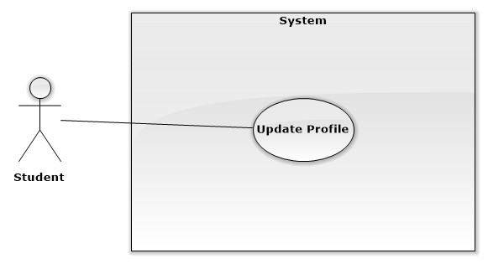

**Figure 5: <Student> Update Profile Use Case Diagram**

|  |  |  |  |
| --- | --- | --- | --- |
| **USE CASE – STU002** | | | |
| **Use Case No.** | STU002 | **Use Case Version** | 1.0 |
| **Use Case Name** | Update Profile | | |
| **Author** | Vu Nhat Anh Khoa | | |
| **Date** | 25/09/2015 | **Priority** | Normal |
| **Actor:**   * Student   **Summary:**   * This use case allows users to update their profile information.   **Goal:**   * New information is updated to database.   **Triggers:**   * User clicks “Edit information” link while on the Profile screen.   **Preconditions:**   * User logs in with Student role   **Post Conditions:**   * **Success**: The system successfully updates new information to database. * **Fail:** The system shows an error message.   **Main Success Scenario:**   |  |  |  | | --- | --- | --- | | Step | Actor Action | System Response | | 1 | User clicks “Edit information” link from Profile screen | Navigate user to Edit Profile screen and show the following form:   * + Label: “Số điện thoại”, textbox   + Label: “Địa chỉ”, textbox   + Label: “Số điện thoại của phụ huynh”, textbox   + Label: “Email của phụ huynh”, textbox   + Update button | | 2 | User alters the information in the form [Alternative Scenario] |  | | 3 | User clicks update button | * System updates new information to database. * Redirect user to Profile screen with new information presenting. |   **Alternative Scenario:**   |  |  |  | | --- | --- | --- | | Step | Actor Action | System Response | | 1 | User empties the fields |  | | 2 | User clicks update button | * System keeps current information in database. * Redirect user to Profile screen with current information presenting. |   **Exceptions:**   |  |  |  | | --- | --- | --- | | No | Actor Action | System Response | | 1 | Cannot connect to server. | System shows error message: “Cannot connect to server.” |   **Relationships:** N/A  **Business Rules:**   * User’s profile is always loaded from the system * In successful scenario, new information will be updated to the system * Reloaded Profile screen will show updated information * If user leave the fields blank, current information will be kept. | | | |

###### <Student> View Study Progress Use Case Diagram

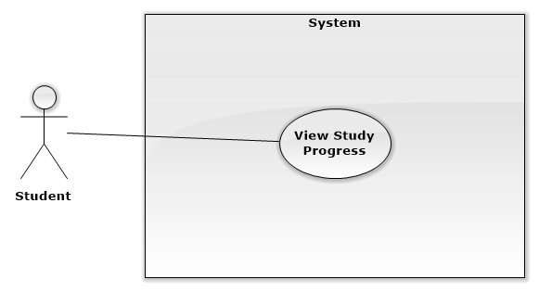

**Figure: <Student> View Studies Progress Use Case Diagram**

|  |  |  |  |
| --- | --- | --- | --- |
| **USE CASE – STU005** | | | |
| **Use Case No.** | STU005 | **Use Case Version** | 1.0 |
| **Use Case Name** | View Studied Progress | | |
| **Author** | Vu Nhat Anh Khoa | | |
| **Date** | 25/09/2015 | **Priority** | Normal |
| **Actor:**   * Student   **Summary:**   * This use case allows users to view their past semesters and subjects, as well as their incomplete subjects.   **Goal:**   * A list of subjects will be shown to user.   **Triggers:**   * User clicks “Các khóa đã học” tab on the navigation menu on the left for the Finished Semesters screen. * User clicks “Các môn chưa hoàn thành” tab on the navigation menu on the left for the Incomplete Subjects scene.   **Preconditions:**   * User logs in with Student role   **Post Conditions:**   * **Success**: The system successfully shows a list of subjects in tabular form. * **Fail:** The system shows an error message.   **Main Success Scenario:**   |  |  |  | | --- | --- | --- | | Step | Actor Action | System Response | | 1 | User clicks “Các khóa đã học” tab [Alternative Scenario] | Navigate user to Finished Semesters screen and show information box containing the latest semester user has taken   * System will show a list of subjects in tabular form and order by subject code. * The table contain the following columns:   + First column contains order number labeled as “STT”.   + Second column contains subject code labeled as “Mã Môn”.   + Third column contains subject name labeled as “Tên Môn”.   + Fourth column contains the number of credits labeled as “Số Tín Chỉ”   + Fifth column contains the semester’s half information labeled as “Half”   + Sixth column contains the grade of the subject labeled as “Điểm Trung Bình”   + Seventh column contains the status of the subject labeled as “Trạng Thái”   + The last column contains additional note for specific subjects labeled as “Ghi Chú” | | 2 | User selects a specific semester from a scroll down box | * System will show a list of subjects in tabular form and order by subject code in different semester with the columns as the same as above |   **Alternative Scenario:**   |  |  |  | | --- | --- | --- | | Step | Actor Action | System Response | | 1 | User clicks “Các môn chưa hoàn thành” tab | Navigate user to Incomplete Subjects screen and show information box containing the subjects that didn’t meet requirements   * System will show a list of subjects in tabular form and order by subject code. * The table contain the following columns:   + First column contains order number labeled as “STT”.   + Second column contains subject code labeled as “Mã Môn”.   + Third column contains subject name labeled as “Tên Môn”.   + Fourth column contains the number of credits labeled as “Số Tín Chỉ”   + Fifth column contains the semester the subjects took place labeled as “Học kỳ”   + Sixth column contains the status of the subject labeled as “Trạng Thái”   + The last column contains additional note for specific subjects labeled as “Ghi Chú” |   **Exceptions:**   |  |  |  | | --- | --- | --- | | No | Actor Action | System Response | | 1 | Cannot connect to server. | System shows error message: “Cannot connect to server.” |   **Relationships:** N/A  **Business Rules:**   * All data is loaded from the system’s database | | | |

###### <Student> View Finance Status Use Case Diagram

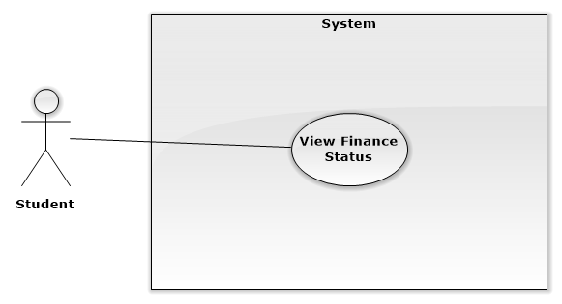

**Figure: <Student> View Finance Status Use Case Diagram**

|  |  |  |  |
| --- | --- | --- | --- |
| **USE CASE – STU004** | | | |
| **Use Case No.** | STU004 | **Use Case Version** | 1.0 |
| **Use Case Name** | View Finance Status | | |
| **Author** | Vu Nhat Anh Khoa | | |
| **Date** | 25/09/2015 | **Priority** | Normal |
| **Actor:**   * Student   **Summary:**   * This use case allows users to view all their past tuition payments and the tuition payment status for the next semester.   **Goal:**   * A list of semesters with the tuition and payment status will be shown to user.   **Triggers:**   * User clicks “Trạng thái đóng học phí” tab on the navigation menu on the left for the Tuition Payment Status screen * User clicks “ Trạng thái đóng tiền học lại” tab on the navigation menu on the left for the Retake Course Payment Status screen   **Preconditions:**   * User logs in with Student role   **Post Conditions:**   * **Success**: The system successfully shows a list of semesters with the tuition and payment status in tabular form. * **Fail:** The system shows an error message.   **Main Success Scenario:**   |  |  |  | | --- | --- | --- | | Step | Actor Action | System Response | | 1 | User clicks “Trạng thái đóng học phí” tab [Alternative Scenario] | * Navigate user to Tuition Payment Status screen * System will show a list of semesters with the tuition and payment status in tabular form and order by semester. * The table contain the following columns:   + First column contains order number labeled as “STT”.   + Second column contains the semester labeled as “Học Kỳ”.   + Third column contains the payment status labeled as “Trạng thái”.   + Fourth column contains the date of money transmission labeled as “Ngày Nộp”   + Fifth column contains the transmission deadline labeled as “Hạn chót”   + Sixth column contains the link to the detail transmission labeled as “Chi tiết” | | 2 | User clicks a “Chi tiết” link in the table | * System will show a pop-up page containing following information:   + User’s full name labeled as “Tên”: text.   + User’s code labeled as “MSSV”: text.   + The payment description labeled as “Nội dung đóng tiền”: text.   + User’s tuition status labeled as “Tình trạng”: text   + The original tuition charge labeled as “Mức học phí”: text   + The deduction fees labeled as “Khoản trừ”: text   + The tuition charge after deduction labeled as “Cần Nộp”: text   + The tuition payment status labeled as “Trạng thái”: text   + The transmission date labeled as “Ngày nộp”: text   + The bank in which student transmit the fees from labeled as “Ngân hàng”: text |   **Alternative Scenario:**   |  |  |  | | --- | --- | --- | | Step | Actor Action | System Response | | 1 | User clicks “Trạng thái đóng học phí” tab | * Navigate user to Tuition Payment Status screen * System will show a list of semesters with the tuition and payment status in tabular form and order by semester. * The table contain the following columns:   + First column contains order number labeled as “STT”.   + Second column contains the subject code labeled as “Mã môn”.   + Third column contains subject name labeled as “Tên Môn”.   + Fourth column contains the payment status labeled as “Trạng thái”.   + Fifth column contains the date of money transmission labeled as “Ngày Nộp   + Sixth column contains the transmission deadline labeled as “Hạn chót”   + The last column contains the link to the detail transmission labeled as “Chi tiết” | | 2 | User clicks a “Chi tiết” link in the table | * System will show a pop-up page containing following information:   + User’s full name labeled as “Tên”: text.   + User’s code labeled as “MSSV”: text.   + The payment description labeled as “Nội dung đóng tiền”: text.   + User’s tuition status labeled as “Tình trạng”: text   + The original tuition charge labeled as “Mức học phí”: text   + The deduction fees labeled as “Khoản trừ”: text   + The tuition charge after deduction labeled as “Cần Nộp”: text   + The tuition payment status labeled as “Trạng thái”: text   + The transmission date labeled as “Ngày nộp”: text   + The bank in which student transmit the fees from labeled as “Ngân hàng”: text |   **Exceptions:**   |  |  |  | | --- | --- | --- | | No | Actor Action | System Response | | 1 | Cannot connect to server. | System shows error message: “Cannot connect to server.” |   **Relationships:** N/A  **Business Rules:**   * All information is loaded from the system’s database * For both of the Tuition Payment Status screen and Retake Course Payment Status Screen:   + The tuition status or “Tình trạng” have three values: “Học bổng”, “Tín dụng 50%”, and “Bình thường”   + The tuition payment status or “Trạng thái” have two values: “Đã nộp” and “Chưa nộp”   + In “Chi tiết” pop-up page, “Ngày nộp” will be blank if the tuition payment status (“Trạng thái”) is “Chưa nộp” | | | |

###### <Credit Loan Student> View Credit Debt Use Case

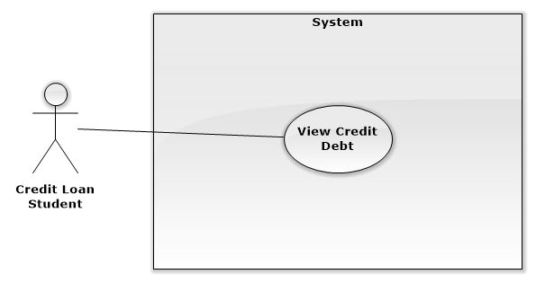

Figure: <Credit Loan Student> View Credit Debt Use Case Diagram

|  |  |  |  |
| --- | --- | --- | --- |
| **USE CASE – STU006** | | | |
| **Use Case No.** | STU006 | **Use Case Version** | 1.0 |
| **Use Case Name** | View Credit Debt | | |
| **Author** | Vu Nhat Anh Khoa | | |
| **Date** | 26/09/2015 | **Priority** | Normal |
| **Actor:**   * CreditStudent   **Summary:**   * This use case allows users to view their own student loans.   **Goal:**   * User’s debt information from database is shown on the screen.   **Triggers:**   * User clicks “Xem lãi vay” tab on the navigation menu on the left   **Preconditions:**   * User logs in with CreditStudent role   **Post Conditions:**   * **Success**: The system successfully shows user’s debt information * **Fail:** The system shows an error message.   **Main Success Scenario:**   |  |  |  | | --- | --- | --- | | Step | Actor Action | System Response | | 1 | User clicks “Xem lãi vay” tab on the navigation menu on the left | * Navigate user to View Debt screen and show two tabular form and order by date. * The first table contain the following columns:   + First column contains the date of the loan labeled as “Date”.   + Second column contains loan description labeled as “Nội dung”.   + Third column contains the tuition fees labeled as “Học phí”.   + Fourth column contains actual tuition charge labeled as “Thực nộp”   + Fifth column contains the loan labeled as “Vay”   + The last column contains additional note for specific subjects labeled as “Ghi Chú” * The second table contain the following columns:   + First column contains the total sum of the loan at the beginning of repayment periods labeled as “Số dư đầu kỳ”.   + Second column contains the interest labeled as “Lãi phát sinh”.   + Third column contains the amount of money pay by the student labeled as “Số tiền thanh toán”.   + Fourth column contains the total sum at the end of repayment periods labeled as “Số dư cuối kỳ”   + Fifth column contains the end date of repayment period labeled as “Lịch trả nợ”   + The last column contains the interest rate labeled as “Lãi suất” |   **Alternative Scenario:** N/A  **Exceptions:**   |  |  |  | | --- | --- | --- | | No | Actor Action | System Response | | 1 | Cannot connect to server. | System shows error message: “Cannot connect to server.” |   **Relationships:** N/A  **Business Rules:**   * The system fetches user only their own debt information from the database. * The tables will be updated when new information is added to the system’s database. * “Số dư cuối kỳ” is calculated by this formula:   ***“Số dư cuối kỳ” = “Số dư đầu kỳ”+ “Lãi phát sinh” - “Thanh toán”***   * “Số dư đầu kỳ” of the next period is “Số dư cuối kỳ” of the previous one. | | | |

###### <Investing Student> View Return Money Status Use Case Diagram

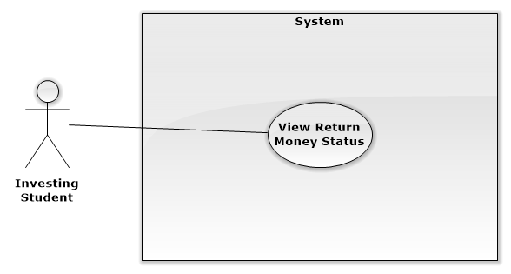

**Figure: <Investing Student> View Return Money Status Use Case Diagram**

|  |  |  |  |
| --- | --- | --- | --- |
| **USE CASE – STU007** | | | |
| **Use Case No.** | STU007 | **Use Case Version** | 1.0 |
| **Use Case Name** | View Return Money Status | | |
| **Author** | Vu Nhat Anh Khoa | | |
| **Date** | 26/09/2015 | **Priority** | Normal |
| **Actor:**   * InvestedStudent   **Summary:**   * This use case allows users to view their own student loans.   **Goal:**   * User’s debt information from database is shown on the screen.   **Triggers:**   * User clicks “Xem lãi vay” tab on the navigation menu on the left   **Preconditions:**   * User logs in with InvestedStudent role   **Post Conditions:**   * **Success**: The system successfully shows user’s debt information * **Fail:** The system shows an error message.   **Main Success Scenario:**   |  |  |  | | --- | --- | --- | | Step | Actor Action | System Response | | 1 | User clicks “Xem nợ tín dụng” tab on the navigation menu on the left | Navigate user to View Debt screen and show information box containing detail information including:   * + User’s full name labeled as “Tên”: text.   + User’s code labeled as “MSSV”: text.   + The original debt labeled as “Số nợ ban đầu”: text   + The current debt labeled as “Số nợ hiện tại”: text   + The money has been payed thus far labeled as “Số tiền đã trả”: text   + The monthly deadline for paying back the loan labeled as “Hạn trả nợ tiếp theo”: text.   + The current interest rate labeled as “Lãi suất hiện tại”: text |   **Alternative Scenario:** N/A  **Exceptions:**   |  |  |  | | --- | --- | --- | | No | Actor Action | System Response | | 1 | Cannot connect to server. | System shows error message: “Cannot connect to server.” |   **Relationships:** N/A  **Business Rules:**   * The system fetches user only their own debt information from the database. * “Số nợ hiện tại”, “Số tiền đã trả”, “Hạn trả nợ tiếp theo”, and “Lãi suất hiện tại” are updated monthly. | | | |

##### <Staff> Overview Use Case

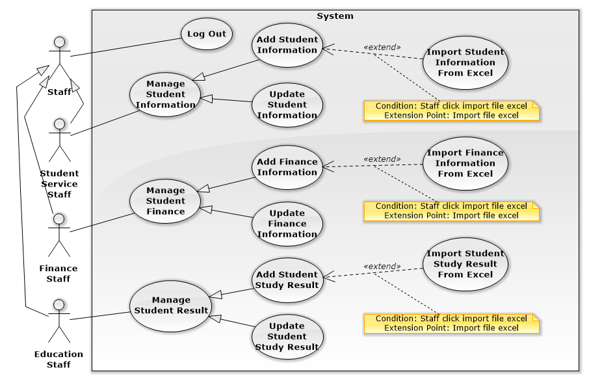

**Figure: <Staff> Overview Use Case**

###### <Staff> Log Out Use Case Diagram

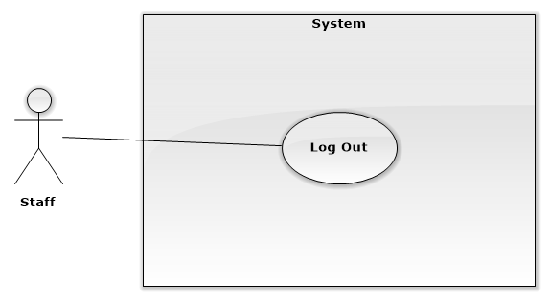

**Figure: <Staff> Log Out Use Case Diagram**

###### <Student Service Staff> Add Student Information Use Case Diagram

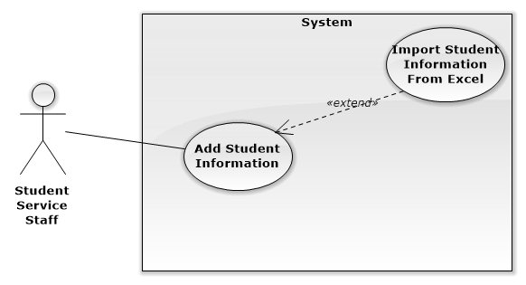

**Figure: <Student Service Staff> Add Student Information Use Case Diagram**

|  |  |  |  |
| --- | --- | --- | --- |
| **USE CASE - STAFF01** | | | |
| **Use Case No.** | STAFF01 | **Use Case Version** | 1.0 |
| **Use Case Name** | Add Student’s Information | | |
| **Author** | Ho Doan Trung | | |
| **Date** | 25/09/2015 | **Priority** | High |
| **Actor:**   * Student Service Staff   **Summary:**   * This use case allows staff enter list of student into the system   **Goal:**   * Allow staff enters student list. List of new students will be added to the system.   **Triggers:**   * The staff will select function to enter student information.   **Preconditions:**   * Staff login to the system with the rights of the Student Service Staff   **Post Conditions:**   * Success: The system will add list of student and notify it was added successfully * Fail: There is no list were added and the system will display error messages to the staff.   **Main Success Scenario:**   |  |  |  | | --- | --- | --- | | **Step** | **Actor Action** | **System Response** | | 1 | Staff will log in to site and enter student’s information. | The system will return:   * Page displayed data in order to add information. | | 2 | Staff sends command "add information" in page displays the data to the system. | The system will display the table include::   * Full name: Free text input * Sex: Radio button * Student ID: Free text input * Date of birth: Date * Address: Free text input * Email: email text input * Date admission: Date * Semester begin: Date * Compulsory English class: Drop down list * Supported: Number input * Parent’s phone number: Number input * Parent’s email: email text input | | 3 | Staff will enter new information and send command "Add" to the system. | The system will add new information and notify it was added successfully. |   **Alternative Scenario:**   |  |  |  | | --- | --- | --- | | **Step** | **Actor Action** | **System Response** | | 1 | Staff send command “Import file excel” on website to system. | The system will display interface allows staff to upload excel files directly from your computer to the system. | | 2 | Staff select files to upload. |  | | 3 | Staff send the command "Upload" to the system. | The system will add data about student’s information then notify it was “added successfully”. |   **Exceptions:**   |  |  |  | | --- | --- | --- | | **Step** | **Actor Action** | **System Response** | | 1 | Length of “Full name” is not in range. | Show error message: “Full name” length must be from 6 to 30 characters!” | | 2 | “Sex” is not specified. | Show error message: “Sex” must be selected!” | | 3 | “Email” is wrong format. | Show error message: “”Email” must be formatted abc@example.fpt.edu.vn!” | | 4 | “Parent’s number” is wrong format. | Show error message: “Parent’s number is the number and length from 8-11 characters!” | | 5 | “Parent’s email” is wrong format. | Show error message: “Parent’s email must be formatted abc@example.com” |   **Relationships:** N/A  **Business Rules:**   * List of student was displayed by alphabet * List of student was divied into some pages, each page display 50 students. | | | |

###### <Student Service Staff> Update Student Information Use Case Diagram

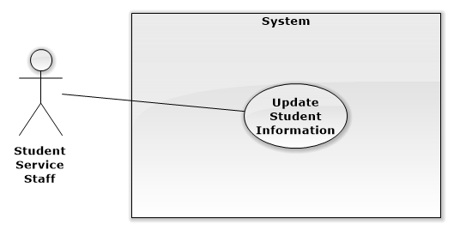

**Figure: < Student Service Staff > Update Student Informmation Use Case Diagram**

|  |  |  |  |
| --- | --- | --- | --- |
| **USE CASE -** STAFF02 | | | |
| **Use Case No.** | STAFF02 | **Use Case Version** | 1.0 |
| **Use Case Name** | Update Student’s Information | | |
| **Author** | Ho Doan Trung | | |
| **Date** | 25/09/2015 | **Priority** | High |
| **Actor:**   * Student Service Staff   **Summary:**   * This use case allows staff update student’s information.   **Goal:**   * Allow staff update student’s information. Student’s information will be updated to the system.   **Triggers:**   * The staff will select a row in list student and send command “Update”.   **Preconditions:**   * Staff login to the system with the rights of the Student Service Staff   **Post Conditions:**   * Success: The system will update student’s information and notify it was updated success full. * Fail: There is no student’s information were updated and the system will display error messages to the staff.   **Main Success Scenario:**   |  |  |  | | --- | --- | --- | | **Step** | **Actor Action** | **System Response** | | 1 | Staff choose one line in the table and then send command "Update" to the system to update information. | The system will display a table allows staff to edit information from the selected line include:   * Full name: Free text input * Sex: Radio button * Student ID: Free text input * Date of birth: Date * Address: Free text input * Email: email text input * Date admission: Date * Semester begin: Date * Compulsory English class: Drop down list * Supported: Number input * Parent’s phone number: Number input * Parent’s mail: email text input | | 2 | Staff choose the information they need to be updated to edit and then send command "Update" to the system. | The system will update new information and notify it was updated successfully. |   **Alternative Scenario:**   |  |  |  | | --- | --- | --- | | **Step** | **Actor Action** | **System Response** | | 1 | Staff enter new information in the wrong format. | The system informs error |   **Exceptions:**   |  |  |  | | --- | --- | --- | | **Step** | **Actor Action** | **System Response** | | 1 | Length of “Full name” is not in range. | Show error message: “Full name” length must be from 6 to 30 characters!” | | 2 | “Sex” is not specified. | Show error message: “Sex” must be selected!” | | 4 | “Parent’s number” is wrong format. | Show error message: “Parent’s number is the number and length from 8-11 characters!” | | 5 | “Parent’s email” is wrong format. | Show error message: “Parent’s email must be formatted abc@example.com” |   **Relationships:** N/A  **Business Rules:**   * Components was marked is compulsory components and it cann’t blank. * Some information cann’t update include: Student’s email, Student ID, Semester begin, Compulsory English class, Date admission. | | | |

###### <Finance Staff> Add Finance Information Use Case Diagram

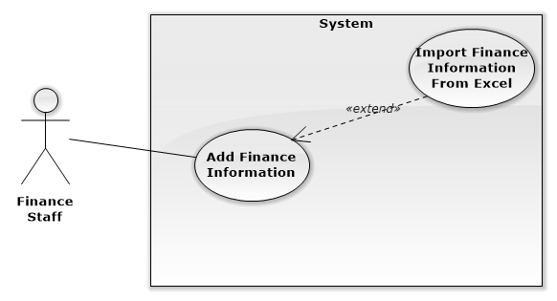

**Figure: <Finance Staff> Add Finance Information Use Case Diagram**

|  |  |  |  |
| --- | --- | --- | --- |
| **USE CASE -** STAFF03 | | | |
| **Use Case No.** | STAFF03 | **Use Case Version** | 1.0 |
| **Use Case Name** | Add Finance Information | | |
| **Author** | Ho Doan Trung | | |
| **Date** | 25/09/2015 | **Priority** | High |
| **Actor:**   * Finance Staff   **Summary:**   * This use case allows staff to enter the system about financial information of FPT University.   **Goal:**   * Allow staff to enter financial information. It will be added to the system.   **Triggers:**   * The staff will select function to enter financial information.   **Preconditions:**   * Staff login to the system with the rights of the Financial Staff   **Post Conditions:**   * Success: Financial information will be added to the system and then notify it was added successfully * Fail: There is no list were added and the system will display error messages to the staff.   **Main Success Scenario:**   |  |  |  | | --- | --- | --- | | **Step** | **Actor Action** | **System Response** | | 1 | Staff sends command "add information" in page displays the data to the system. | The system will display the table include:   * Tuition fee: Number input. * Relearn fee: Number input. * Exchange rate: Number input. * Fine level: Number input. * “Tiền thu trong kỳ”: Number input. | | 2 | Staff will enter new information and send command "Add" to the system. | The system will add new information and notify it was added successfully |   **Alternative Scenario:**   |  |  |  | | --- | --- | --- | | **Step** | **Actor Action** | **System Response** | | 1 | Staff send command “Import file excel” to system. | The system will display interface allows staff to upload excel files directly from your computer to the system. | | 2 | Staff selects files to upload. |  | | 3 | Staff send the command "Upload" to the system. | The system will add data finance’s information then notify it was “added successfully”. |   **Exceptions:**   |  |  |  | | --- | --- | --- | | **Step** | **Actor Action** | **System Response** | | 1 | “Tuition fee” is wrong format | Show error message: “”Tuition fee” must be a number!” | | 2 | “Relearn fee” is wrong format | Show error message: “”Relearn fee” must be a number!” | | 3 | “Exchange rate” is wrong format | Show error message: “”Exchange rate” must be a number!” | | 4 | “Fine level” is wrong format | Show error message: “”Fine level” must be a number!” | | 5 | “Tiền thu trong kỳ” is wrong format. | Show error message: ““Tiền thu trong kỳ ” must be a number!” |   **Relationships:** N/A  **Business Rules:** N/A | | | |

###### <Finance Staff> Update Finance Information Use Case Diagram

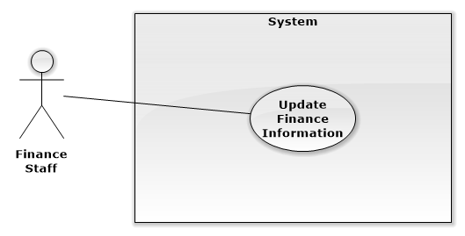

**Figure: <Finance Staff> Update Finance Information Use Case Diagram**

|  |  |  |  |
| --- | --- | --- | --- |
| **USE CASE -** STAFF04 | | | |
| **Use Case No.** | STAFF04 | **Use Case Version** | 1.0 |
| **Use Case Name** | Update Finance Information | | |
| **Author** | Ho Doan Trung | | |
| **Date** | 25/09/2015 | **Priority** | High |
| **Actor:**   * Finance Staff   **Summary:**   * This use case allows staff to update about financial information of FPT University.   **Goal:**   * Allow staff to update financial information. It will be updated to the system.   **Triggers:**   * The staff will send command “Update financial information” to system.   **Preconditions:**   * Staff login to the system with the rights of the Financial Staff   **Post Conditions:**   * Success: Financial information will be updated to the system and then notify it was updated successfully * Fail: There is no finance’s informatuon were updated and the system will display error messages to the staff.   **Main Success Scenario:**   |  |  |  | | --- | --- | --- | | **Step** | **Actor Action** | **System Response** | | 1 | Staff choose one line in the table and then send command "Update" to the system to update information. | The system will display a table allows staff to edit information from the selected line include:   * Tuition fee: Number input. * Relearn fee: Number input. * Exchange rate: Number input. * Fine level: Number input. * Tiền thu trong kỳ: Number input. | | 2 | Staff can choose the information they need to be updated to edit and then send the command "Update" to the system. | The system will update new information and notify it was added successfully. |   **Alternative Scenario:**   |  |  |  | | --- | --- | --- | | **Step** | **Actor Action** | **System Response** | | 1 | Staff enter new information in the wrong format. | The system informs error |   **Exceptions:**   |  |  |  | | --- | --- | --- | | **Step** | **Actor Action** | **System Response** | | 1 | “Tuition fee” is wrong format | Show error message: “”Tuition fee” must be a number!” | | 2 | “Relearn fee” is wrong format | Show error message: “”Relearn fee” must be a number!” | | 3 | “Exchange rate” is wrong format | Show error message: “”Exchange rate” must be a number!” | | 4 | “Fine level” is wrong format | Show error message: “”Fine level” must be a number!” | | 5 | “ Tiền thu trong kỳ ” is wrong format. | Show error message: “”Tiền thu trong kỳ ” must be a number!” |   **Relationships:** N/A  **Business Rules:** N/A | | | |

###### <Education Staff> Add Student Study Result Use Case Diagram

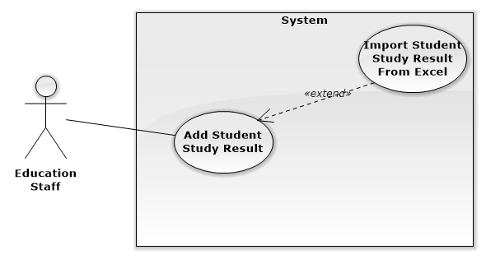

**Figure: <Education Staff> Add Student Study Result Use Case Diagram**

|  |  |  |  |
| --- | --- | --- | --- |
| **USE CASE -** STAFF05 | | | |
| **Use Case No.** | STAFF05 | **Use Case Version** | 1.0 |
| **Use Case Name** | Add Student Study Result | | |
| **Author** | Ho Doan Trung | | |
| **Date** | 25/09/2015 | **Priority** | High |
| **Actor:**   * Education Staff   **Summary:**   * This use case allows staff to enter to the system study results of student after each semester   **Goal:**   * Allow staff to enter the final study results. It will be added to the system   **Triggers:**   * The staff will send command “Add study results ” to the system   **Preconditions:**   * Staff must login to the system with the right of Education Staff   **Post Conditions:**   * Success: Final study results will be added to the system and then notify it was added successfully * Fail: There is no information were added and the system will display error messages to the staff.   **Main Success Scenario:**   |  |  |  | | --- | --- | --- | | **Step** | **Actor Action** | **System Response** | | 1 | Staff will login to site and enter study result | The system will return:   * Page displayed data in order to add or edit information. | | 2 | Staff sends command "add information" in page displays the data to the system. | The system will display the table include::   * Student ID: Free text input * Full name: Free text input * Mail: Email input * Score: Number input * Status: Free text input * Subject: Free text input | | 3 | Staff will enter new information. |  | | 4 | Staff send command "Add" to the system. | The system will add new information and notify it was added successfully. |   **Alternative Scenario:**   |  |  |  | | --- | --- | --- | | **Step** | **Actor Action** | **System Response** | | 1 | Staff send command “Import file excel” to system. | The system will display interface allows staff to upload excel files directly from your computer to the system. | | 2 | Staff selects files to upload. |  | | 3 | Staff send the command "Upload" to the system. | The system will add data learning results then notify it was “added successfully”. |   **Exceptions:**   |  |  |  | | --- | --- | --- | | **Step** | **Actor Action** | **System Response** | | 1 | Length of “Full name” is not in range. | Show error message: ““Full name” length must be from 6 to 30 characters!” | | 2 | “Score” is wrong format. | Show error message: ""Score "must be the number and has a value greater than 0 and less than 10!" | | 3 | “Email” is wrong format. | Show error message: “”Email” phải đúng định dạng abc@example.fpt.edu.vn!” |   **Relationships:** N/A  **Business Rules:** N/A | | | |

###### <Education Staff> Update Student Study Result Use Case Diagram

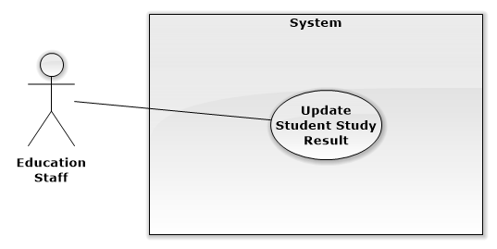

**Figure: <Education Staff> Update Student Study Result**

|  |  |  |  |
| --- | --- | --- | --- |
| **USE CASE -** STAFF06 | | | |
| **Use Case No.** | STAFF06 | **Use Case Version** | 1.0 |
| **Use Case Name** | Update Student Study Result | | |
| **Author** | Ho Doan Trung | | |
| **Date** | 25/09/2015 | **Priority** | High |
| **Actor:**   * Education Staff   **Summary:**   * This use case allows staff update to the system study results of student after each semester   **Goal:**   * Allow staff to update study results. It will be updated to the system.   **Triggers:**   * The staff will send command “Update study results” to the system.   **Preconditions:**   * Staff must login to the system with the right of Education Staff   **Post Conditions:**   * Success: Final study results will be updated to the system and then notify it was added successfully * Fail: There is no information were updated and the system will display error messages to the staff.   **Main Success Scenario:**   |  |  |  | | --- | --- | --- | | **Step** | **Actor Action** | **System Response** | | 1 | Staff choose one line in the table and then send command "Update" to the system to update information. | The system will display a table allows staff to edit information from the selected line include:   * Student ID: Free text input * Full name: Free text input * Mail: Email input * Score: Number input * Status: Free text input * Subject: Free text input | | 2 | Staff can choose the information they need to be updated to edit. |  | | 3 | Staff send the command "Update" to the system. | The system will update new information and notify it was added successfully. |   **Alternative Scenario:**   |  |  |  | | --- | --- | --- | | **Step** | **Actor Action** | **System Response** | | 1 | Staff enter new information in the wrong format. | The system informs error |   **Exceptions:**   |  |  |  | | --- | --- | --- | | **Step** | **Actor Action** | **System Response** | | 1 | Length of “Full name” is not in range. | Show error message: ““Full name” length must be from 6 to 30 characters!” | | 2 | “Score” is wrong format. | Show error message: ""Score "must be the number and has a value greater than 0 and less than 10!" | | 3 | “Email” is wrong format. | Show error message: “”Email” phải đúng định dạng abc@example.fpt.edu.vn!” |   **Relationships:** N/A  **Business Rules:** N/A | | | |

##### <Manager> Overview Use Case

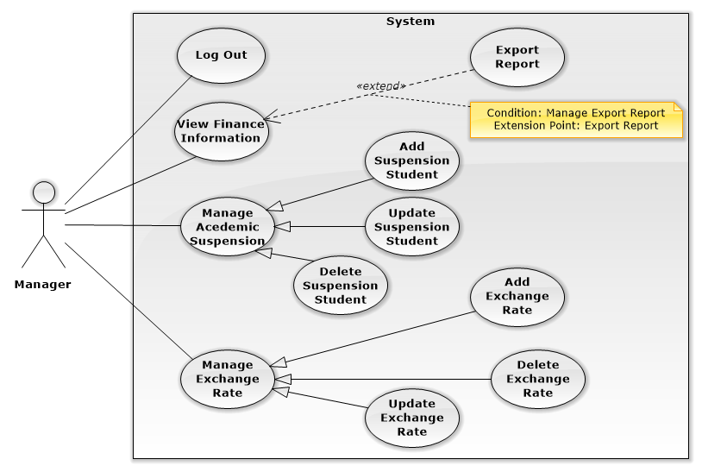

**Figure: <Manager> Overview Use Case**

###### <Manager> Log Out Use Case Diagram

###### <Manager> View Finance Information Use Case Diagram

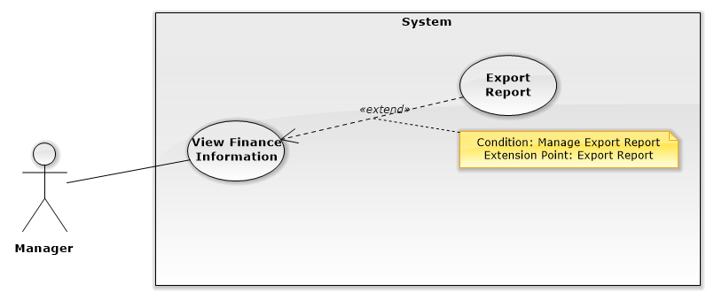

**Figure: <Manager> View Finance Information Use Case Diagram**

|  |  |  |  |
| --- | --- | --- | --- |
| USE CASE – M01 | | | |
| Use Case No. | M01 | **Use Case Version** | 1.0 |
| Use Case Name | View Finance Information | | |
| Author | AnhLT | | |
| Date | 27/09/2015 | **Priority** | Medium |
| Actor:   * Manager.   Summary:   * This use case shows finance information of student.   Goal:   * User view list all finance information of student.   Triggers:   * User send command View finance Information.   Preconditions:   * User must login into the system with role manager.   Post Conditions:   * Success: Show the list finance information of student to the user. * Fail: Show error message.   Main Success Scenario:   |  |  |  | | --- | --- | --- | | Step | Actor Action | System Response | | 1 | User go to view list of tuitions fees | List finance information of student will be shown with following information :   * Number * Name of student * Type of student * Type of tuition * The money student must pay * The money student has paid * Pay status * A link to “Finance Information Detail” | | 2 | User select student to view detail finance information | The student finance detail will be shown with following information :   * Student name * Student code * Type of student * List of terms student payed tuition fees for. Display will show some information:   + Required amount   + Amount paid   + Time paid | | 3 | User send command “export report” to system | System send response to user report. |   Alternative Scenario 1:   |  |  |  | | --- | --- | --- | | Step | Actor Action | System Response | | 1 | User go to view list credit loans student | List credit loans student will be shown with following information :   * Number * Student code * Name of student * Type of student * Study status of student (studying or graduated) * Student loan amount * Interest arising * Total * Detail : link to finance information of student | | 2 | User select student to view detail finance information | The student finance detail will be shown with following information :   * Student code * Name of student * Status * Amount paid * Time paid: date time * Debit * Interest | | 3 | User send command “export report” to system | System send response to user report. |   Alternative Scenario 2:   |  |  |  | | --- | --- | --- | | Step | Actor Action | System Response | | 1 | User go to view list “invest with you” | List “invest with you” student will be shown with following information :   * Number * Student code * Name of student * Type of student * Study status of student (studying or graduated) * A link to finance information of student | | 2 | User select student to view detail finance information | The student finance detail will be shown with following information :   * Student code * Name of student * Type of student * Amount paid * Time paid: date time * Status * Bank name | | 3 | User send command “export report” to system | System send response to user report. |   Alternative Scenario 3:   |  |  |  | | --- | --- | --- | | No | Actor Action | System Response | | 1 | There are no data | Show message to notify that there are no data. |   Exceptions: N/A  Relationships: N/A  Business Rules:   * The information is loaded from the system. * Tuition list is sorted per term. * Search bar on the top help user finding information of student faster. * Pagination must be displayed if number of student larger than 10. | | | |

###### <Manager> Manage Acedemic Suspension Use Case Diagram

###### <Manager> Manage Exchange Rate Use Case Diagram

##### <Admin> Overview Use Case

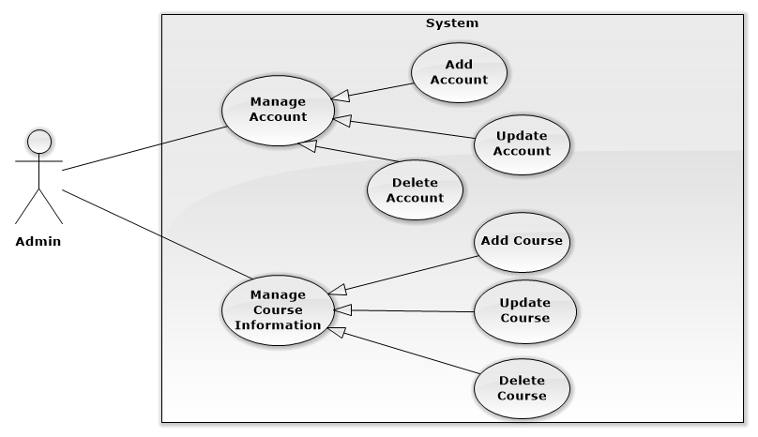

**Figure: <Admin> Overview Use Case**

###### <Admin> Manage Account Use Case Diagram

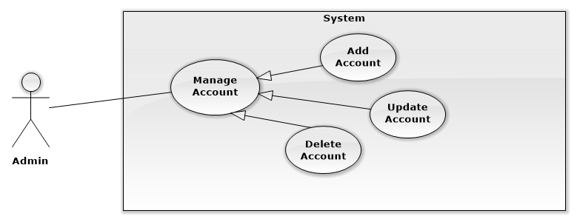

**Figure: <Admin> Manage Account Use Case Diagram**

|  |  |  |  |
| --- | --- | --- | --- |
| **USE CASE** - Admin01 | | | |
| **Use Case No.** | Admin01 | **Use Case Version** | 1.0 |
| **Use Case Name** | Update Account | | |
| **Author** | Ho Doan Trung | | |
| **Date** | 25/09/2015 | **Priority** | High |
| **Actor:**   * Admin   **Summary:**   * This use case allows admin to update account for the system.   **Goal:**   * Allows admin to update account. Account will be updated to the system.   **Triggers:**   * Admin will choose account and send command “Update account” to the system.   **Preconditions:**   * User must log in the system with admin role.   **Post Conditions:**   * **Success:** Account will be updated. Display success message. * **Fail:** No account will be updated. Display error message.   Main Success Scenario:   |  |  |  | | --- | --- | --- | | **Step** | **Actor Action** | **System Response** | | 1 | Admin choose a account in table |  | | 2 | Admin send command “Update account ” | The system will display a table allows admin to edit information from the selected line include:   * “Username”: Free text input. * “Email”: Email text input. * “Password”: Password input. * Role: Choose role in list role. | | 3 | Admin choose the information they need to be updated to edit. |  | | 4 | Admin send command "Update" to the system | The system will update new information and notify it was updated successfully. |   Alternative Scenario:   |  |  |  | | --- | --- | --- | | **Step** | **Actor Action** | **System Response** | |  |  |  |   Exceptions:   |  |  |  | | --- | --- | --- | | **Step** | **Actor Action** | **System Response** | | 1 | Length of “Username” is not in range. | Show error message: “Username ” length must be from 8 to 30 characters!” | | 2 | Length of “Password” is not in range. | Show error message: “Password” length must be from 8 to 32 characters!” | | 3 | “Email” is wrong format. | Show error message: “Email must be formatted abc@example.com” |   **Relationships**: N/A  **Business Rules:** | | | |

|  |  |  |  |
| --- | --- | --- | --- |
| USE CASE - Admin02 | | | |
| Use Case No. | Admin02 | **Use Case Version** | 1.0 |
| Use Case Name | Create Account | | |
| Author | Ho Doan Trung | | |
| Date | 25/09/2015 | **Priority** | High |
| Actor:   * Admin   Summary:   * This use case allows admin to create new user account for the system.   Goal:   * Allows admin to create new user account. New user account will be added to the system.   Triggers:   * Admin send command “Create new account” to the system.   Preconditions:   * User must log in the system with admin role.   Post Conditions:   * Success: New user account will be added and redirect to “Manage User” page. Display success message. * Fail: No account will be created. Display error message.   Main Success Scenario:   |  |  |  | | --- | --- | --- | | **Step** | **Actor Action** | **System Response** | | 1 | Admin send command “Thêm nhân viên” to the system. | Navigate to “Thêm nhân viên” pop-up which contains:   * Username: Free text input. * Email: Email input. * Role: Drop down list. | | 2 | Admin fills data to the form. |  | | 3 | Admin send command “Thêm” to the system. | Insert new user account to the system and redirect to “Quản lý nhân viên” page. |   Alternative Scenario:   |  |  |  | | --- | --- | --- | | **Step** | **Actor Action** | **System Response** | | 1 | Admin clicks outside pop-up. | Pop-up dismiss and still keep data for next time open. |   Exceptions:   |  |  |  | | --- | --- | --- | | **Step** | **Actor Action** | **System Response** | | 1 | Length of username is not in range. | Show error message: “Username length must be from 6 to 30 characters!” | | 2 | Length of password is not in range. | Show error message: “Password length must be from 8 to 30 characters!” | | 3 | “Email” does not right format. | Show error message: “Email must be right format abc@fpt.edu.vn!“ | | 4 | Role is not specified. | Show error message: “The role must be selected!” |   Relationships: N/A  Business Rules:   * Each created account must be in active state when it’s inserted to system. * Password is generated random by system that contains 8 character, mixes both number and letter. * Password is sent to user email automatically. * User must change password when they login system for the first time. | | | |

|  |  |  |  |
| --- | --- | --- | --- |
| USE CASE - Admin03 | | | |
| Use Case No. | Admin03 | **Use Case Version** | 1.0 |
| Use Case Name | Delete Account | | |
| Author | Ho Doan Trung | | |
| Date | 25/09/2015 | **Priority** | High |
| Actor:   * Admin   Summary:   * This use case allows admin to delete user account for the system.   Goal:   * Allows admin to delete user account. Old user account will be deleted to the system.   Triggers:   * Admin send command “Delete account” to the system.   Preconditions:   * User must log in the system with admin role.   Post Conditions:   * Success: Old user account will be deleted and redirect to “Manage User” page. Display success message. * Fail: No account will be deleted. Display error message.   Main Success Scenario:   |  |  |  | | --- | --- | --- | | **Step** | **Actor Action** | **System Response** | | 1 | Admin choose a account in table |  | | 2 | Admin send command “Delete account” | Show message: “Do you want to delete this account?” | | 3 | Admin send command “Yes” to the system. | User account will be deleted and system show message: “Delete Successful!” |   Alternative Scenario:   |  |  |  | | --- | --- | --- | | **Step** | **Actor Action** | **System Response** | |  |  |  |   Exceptions:   |  |  |  | | --- | --- | --- | | **Step** | **Actor Action** | **System Response** | | 1 |  |  |   Relationships: N/A  Business Rules: | | | |

###### <Admin> Manage Course Information Use Case Diagram

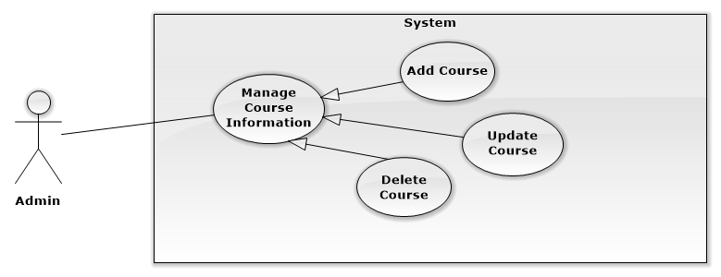

**Figure: <Admin> Manage Course Information Use Case Diagram**

|  |  |  |  |
| --- | --- | --- | --- |
| **USE CASE -** Admin04 | | | |
| **Use Case No.** | Admin04 | **Use Case Version** | 1.0 |
| **Use Case Name** | Add Course | | |
| **Author** | Ho Doan Trung | | |
| **Date** | 25/09/2015 | **Priority** | High |
| **Actor:**   * Admin   **Summary:**   * This use case allows admin enter list of course into the system   **Goal:**   * Allow admin enters course list. List of course will be added to the system.   **Triggers:**   * The admin will send command “Add course” to the system.   **Preconditions:**   * User must login to the system with the rights of the admin.   **Post Conditions:**   * Success: The system will add list of course and notify it was added successfully * Fail: There is no list were added and the system will display error messages to the admin.   **Main Success Scenario:**   |  |  |  | | --- | --- | --- | | **Step** | **Actor Action** | **System Response** | | 1 | Staff sends command "add course" in page displays the data to the system. | The system will display the table include::   * “Tên môn học”: Free text input * “Số tín chỉ”: Number input * “Môn tiên quyết”: Drop down list các môn học * Mã môn: Free text input | | 2 | Staff will enter new information |  | | 3 | Staff send command "Add" to the system. | The system will add new information and notify it was added successfully. |   **Alternative Scenario:**   |  |  |  | | --- | --- | --- | | **Step** | **Actor Action** | **System Response** | | 1 | Staff send command “Import file excel” on website to system. | The system will display interface allows staff to upload excel files directly from your computer to the system. | | 2 | Staff select files to upload and then send the command "Upload" to the system. | The system will add data about course’s information then notify it was “added successfully”. |   **Exceptions:**   |  |  |  | | --- | --- | --- | | **Step** | **Actor Action** | **System Response** | | 1 | Length of “Tên môn học” is not in range. | Show error message: “Full name” length must be from 6 to 30 characters!” | | 2 | “Mã môn” is wrong format. | Show error message: “Full name” length must be from 3 to 8 characters!” | | 3 | “Số tín chỉ” is wrong format. | Show error message: “Số tín chỉ phải là số!” |   **Relationships:** N/A  **Business Rules:** | | | |

|  |  |  |  |
| --- | --- | --- | --- |
| USE CASE - Admin05 | | | |
| Use Case No. | Admin05 | **Use Case Version** | 1.0 |
| Use Case Name | Delete Course | | |
| Author | Ho Doan Trung | | |
| Date | 25/09/2015 | **Priority** | High |
| Actor:   * Admin   Summary:   * This use case allows admin to delete course for the system.   Goal:   * Allows admin to delete course. Old course will be deleted to the system.   Triggers:   * Admin send command “Delete course” to the system.   Preconditions:   * User must log in the system with admin role.   Post Conditions:   * Success: Old course will be deleted. Display success message. * Fail: No course will be deleted. Display error message.   Main Success Scenario:   |  |  |  | | --- | --- | --- | | **Step** | **Actor Action** | **System Response** | | 1 | Admin choose a course in table |  | | 2 | Admin send command “Delete course ” | Show message: “Do you want to delete this course ?” | | 3 | Admin send command “Yes” to the system. | User account will be deleted and system show message: “Delete Successful!” |   Alternative Scenario:   |  |  |  | | --- | --- | --- | | **Step** | **Actor Action** | **System Response** | |  |  |  |   Exceptions:   |  |  |  | | --- | --- | --- | | **Step** | **Actor Action** | **System Response** | | 1 |  |  |   Relationships: N/A  Business Rules: | | | |

|  |  |  |  |
| --- | --- | --- | --- |
| USE CASE - Admin06 | | | |
| Use Case No. | Admin06 | **Use Case Version** | 1.0 |
| Use Case Name | Update Course | | |
| Author | Ho Doan Trung | | |
| Date | 25/09/2015 | **Priority** | High |
| Actor:   * Admin   Summary:   * This use case allows admin to update course for the system.   Goal:   * Allows admin to update course. Course will be updated to the system.   Triggers:   * Admin will choose course and send command “Update course” to the system.   Preconditions:   * User must log in the system with admin role.   Post Conditions:   * Success: Course will be updated. Display success message. * Fail: No course will be updated. Display error message.   Main Success Scenario:   |  |  |  | | --- | --- | --- | | **Step** | **Actor Action** | **System Response** | | 1 | Admin choose a course in table |  | | 2 | Admin send command “Update course ” | The system will display a table allows admin to edit information from the selected line include:   * “Tên Môn Học”: Free text input. * “Mã Môn Học”: Free text input. * “Số tín chỉ”: Number input. * “Môn tiên quyết”: Choose option in drop down list. | | 3 | Admin choose the information they need to be updated to edit. |  | | 4 | Admin send command "Update" to the system | The system will update new information and notify it was updated successfully. |   Alternative Scenario:   |  |  |  | | --- | --- | --- | | **Step** | **Actor Action** | **System Response** | |  |  |  |   Exceptions:   |  |  |  | | --- | --- | --- | | **Step** | **Actor Action** | **System Response** | | 1 | Length of “Tên Môn Học” is not in range. | Show error message: “ Tên Môn Học ” length must be from 8 to 30 characters!” | | 2 | Length of “Mã Môn Học” is not in range. | Show error message: “ Mã Môn Học ” length must be from 6 to 10 characters!” | | 3 | “Số Tín Chỉ” is wrong format. | Show error message: “ Số Tín Chỉ is the number!” |   Relationships: N/A  Business Rules: | | | |

##### <Scheduler> Overview Use Case

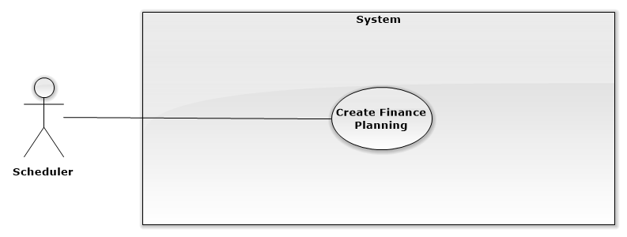

**Figure: <Scheduler> Overview Use Case**

###### <Scheduler> Create finance Planning Use Case Diagram



**Figure: <Scheduler> Create Finance Planning Use Case Diagram**

|  |  |  |  |
| --- | --- | --- | --- |
| USE CASE – System01 | | | |
| Use Case No. | System01 | **Use Case Version** | 1.0 |
| Use Case Name | Create Finance Planning | | |
| Author | Ho Doan Trung | | |
| Date | 25/09/2015 | **Priority** | High |
| Actor:   * System   Summary:   * This use case auto create finance planning in next semester for students.   Goal:   * Auto create finance planning in next semester for students.   Triggers:   * Hệ thống sẽ tự động lập lịch trước thời hạn nhập học 3 tuần.   Preconditions:   * Hệ thống phải nhận được file kế hoạch học tập từ nhân viên đào tạo.   Post Conditions:   * Success: Tự động gửi mail cho sinh viên đúng thời hạn. * Fail: Báo lỗi cho nhân viên biết gửi mail không thành công do không nhận được file kế hoạch học tập.   Main Success Scenario:   |  |  |  | | --- | --- | --- | | **Step** | **Actor Action** | **System Response** | | 1 |  | Hệ thống matching thời gian với kế hoạch học tập có trong hệ thống. | | 2 |  | Hệ thống tự động gửi mail đến các sinh viên. | | 3 |  | Hệ thống hiển thị thông báo đến nhân viên đào tạo: “Đã gửi thành công” và hiển thị danh sách sinh viên đã được gửi mail |   Alternative Scenario:   |  |  |  | | --- | --- | --- | | **Step** | **Actor Action** | **System Response** | |  |  |  |   Exceptions:   |  |  |  | | --- | --- | --- | | **Step** | **Actor Action** | **System Response** | | 1 |  |  |   Relationships: N/A  Business Rules:   * Phải thông báo cho sinh viên trước thời hạn nhập học 3 tuần * Gửi thông báo cho nhân viên đào tạo khi gửi mail thành công * Chỉ gửi cho những sinh viên cần nộp học phí như: sinh viên bình thường, sinh viên vay tín dụng, sinh viên cùng bạn đầu tư. * Điều chỉnh chi phí cần nộp đối với từng đối tượng sinh viên. | | | |

## Software System Attribute

#### Usability

##### Graphic User Interface

* All the texts, labels and alerts will be written in Vietnamese, except some English terms that the school is using.

##### Usability

* The system is easy to use. The school’s staffs will need less than 3 days of training to use the system effectively.
* Students don’t need any training to use the system.

##### Installation

* User can follow installation and manual guide for installation. If there are any problems, users can contact developers for help.

#### Reliability

* System notification success rate is less than 2 failed notifications per 1000 sent.
* System email notification deliver success rate is less than 2 failed deliveries per 1000 sent.
* Scheduler task run at 00:00 every day with 100% execution rate.
* Web service API response success rate is less than 2 failed requests per 10,000 requests.

#### Availability

* **N/A**

#### Security

* All input data will be validated before saving into database.
* All privacy information such as password will be encrypted to ensure security.
* The system automatically authorizes all users when they login to the system.

#### Maintainability

* The system is separated into modules.

#### Portability

* All users can use application on every OS supported web browser.

#### Performance

* Requests from web application are responded in less than 10 seconds at 8 Mbps bandwidth speed.
* Mobile checker application should return card information in less than 1 minute at 8 Mbps bandwidth speed.
* Mobile printer application should write data to NFC card successfully in less than 1 minute at 8 Mbps bandwidth speed.

## Conceptual Diagram

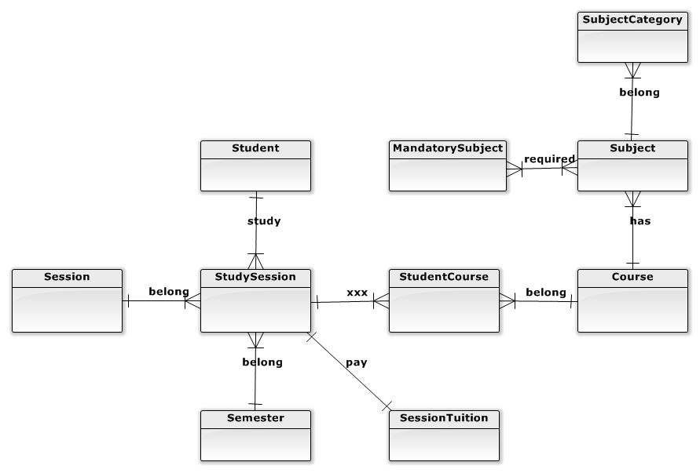

Figure 35: ERD - Conceptual Diagram